At Satellite Healthcare, our mission is to make life better for patients living with kidney disease. Our dedication to patient care extends beyond the doors of our dialysis centers and directly into the communities we serve. Collectively and individually, our organization and staff contribute time, talent and monies to address and build awareness of kidney disease.
The 2019 calendar year held special significance as it marked the 45th anniversary of Satellite Healthcare.
We were founded in 1974 as a not-for-profit dialysis provider by Stanford nephrologist Norman S. Coplon, MD. Over the years, we have become known for informative kidney education, high quality dialysis services and advancing kidney care through research. We are a community asset with no owners, investors or shareholders. Any extra funds from operations are invested back into patient services, new research and education initiatives and to continue our longstanding charitable efforts.
In 2019, our Community Benefit contributions totaled $13.8 million. Satellite Healthcare supported activities of not-for-profit organizations that are working wonders in our neighborhoods. Additionally, we provided scholarships, internships and fellowships. The stories we hear are amazing and we see the ripple effect, as the people we help pass on the benefits of that investment by helping others.
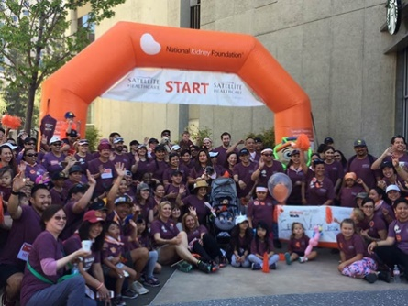
Some highlights include:
- Bringing kidney education and health screenings to at-risk communities, Satellite Healthcare sponsored Kidney Action Day with the American Kidney Fund in San Jose, California and Memphis, Tennessee. The day featured health education, cooking demonstrations, games and screenings for high blood pressure, diabetes and kidney disease. Satellite Healthcare staff participated as volunteers.
- Underscoring the importance of home dialysis, funding was provided to Home Dialyzors United to continue their educational programs and further spread the word about the benefits of dialyzing at home.
- Providing nephrology healthcare professionals with timely information on chronic kidney disease guidelines and standards, medication updates and research, so they may better care for their patients, Satellite Healthcare joined the National Kidney Foundation in making the annual Medical Symposium possible.
Our like-minded organizations have a strong, historic collaborative relationship that spans education, research, advocacy and fundraising that is like no other in the kidney community.
- Talking with others who have chronic kidney disease or are on dialysis is educating and empowering. To capture support group conversations, Satellite Healthcare made a donation to cover fees for videotaping Bay Area Association of Kidney Patients support groups so programs can be extended to broader audiences through their website.
- Working with academic institutions, we provided kidney research grants and we contributed to conferences to shine a light on advancements in patient care. Satellite Healthcare experts often served as speakers, elevating our role as a respected thought leader in kidney care.
This is work we feel privileged to perform and fund. Our greatest lesson is the reality that we can best carry out our responsibility to our patients when we deeply engage in the health of our communities. We look forward to continuing our journey as we strive to prevent the onset of kidney disease. And, if there is a loss of kidney function that we provide early education to delay the start of dialysis. When dialysis is needed that it happens at home and we prepare and support patients through transplantation. This is how we deliver on the promise of making life better for patients with kidney disease.
Sincerely,
Rick Barnett
President & CEO

